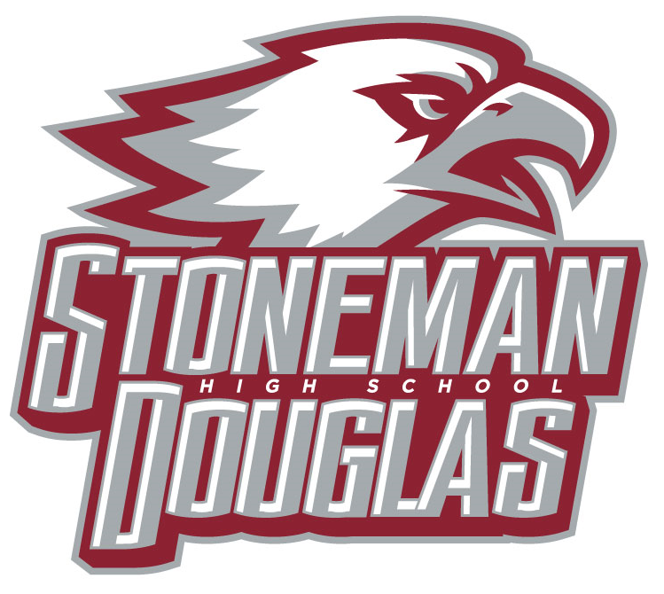

**Meeting Agenda**

**Date:** September 14, 2022

**Time:** 3:15 PM

**Location:** Media Center

1. Welcome/Call to Order/ Review of Agenda
2. Attendance (Roll call)
3. Principal’s Report
   1. SESIR
4. Revision/Approval of May 2022 SAC minutes
5. SAC Voting:
   1. Parent slate, August 30, 2022 during Open House: passed

-Nominations from the floor of additional members

* 1. Teacher slate, August 9, 2022 during Planning: passed

- Nominations from the floor of additional members

* 1. SAC Co-Chairs and secretary elections- completed in May
  2. SAC positions for 2022-2023
  3. SAC By-Laws

1. Meetings dates for 2022-2023

October 12th (SIP vote and review, A+ slate, and new waiver discussion)

December 14th (PSD waiver discussion and new waiver vote)

January 18th (PSD waiver data)

February 9th ( Day of Service)

March 9th (PSD continuation waiver vote and Customer survey)

April 20th (SPBP vote, create a nominating committee)

May 10th (Election for 2022-2023 officers)

1. **A+ plus updates**
2. Officers’ Report
   1. School Improvement Plan (SIP): SIP plan is being worked on
   2. School-wide Positive Behavior Plan (SPBP):Updates
   3. SAC School Accountability Funds: $67,637
      * + - Math and English curriculum planning spent over summer $2815.00
   4. SAF Report
3. Special orders/unfinished business from previous meeting
   1. New business

Announcements/Reminder:

Next meeting: October 12, 2022

1. Adjournment